**Installation of Tomcat-10 on Ubuntu**

* Firstly, create an instance in EC2.
* Log into the VM.

**$** 🡪 **(ssh ubuntu@public_ip_address)**

**$ 🡪 (sudo apt install ansible -y)**

* Open any document to install “Tomcat-10” manually. Refer here for document (<https://www.digitalocean.com/community/tutorials/how-to-install-apache-tomcat-10-on-ubuntu-20-04>).

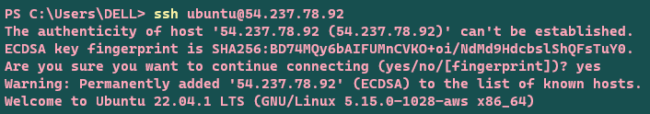

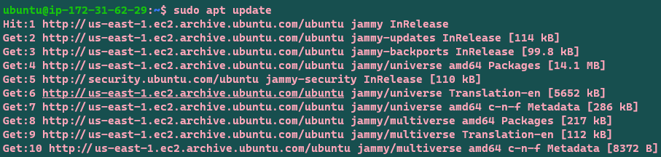

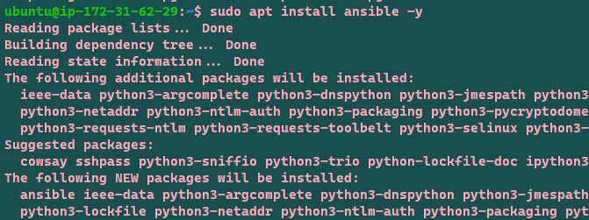

* Create a file in /home/ubuntu as “main.yml” and the paste the playbook written in vscode.

**$** 🡪 **(nano main.yml)**

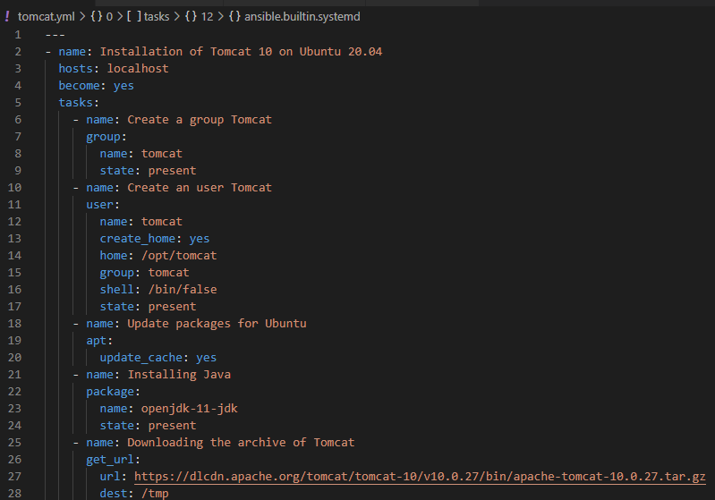

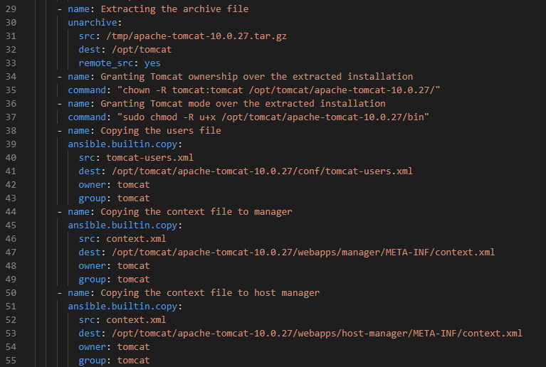

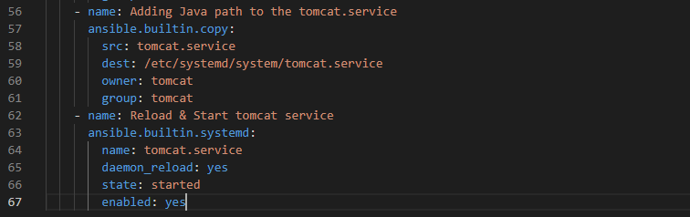

* Now it’s time create few more files like context.xml, tomcat-users.xml & tomcat.service being in /home/ubuntu and paste the content stored in vscode or follow the document.

**$** 🡪 **(nano context.xml)**

**$** 🡪 **(nano tomcat-users.xml)**

**$** 🡪 **(nano tomcat.service)**



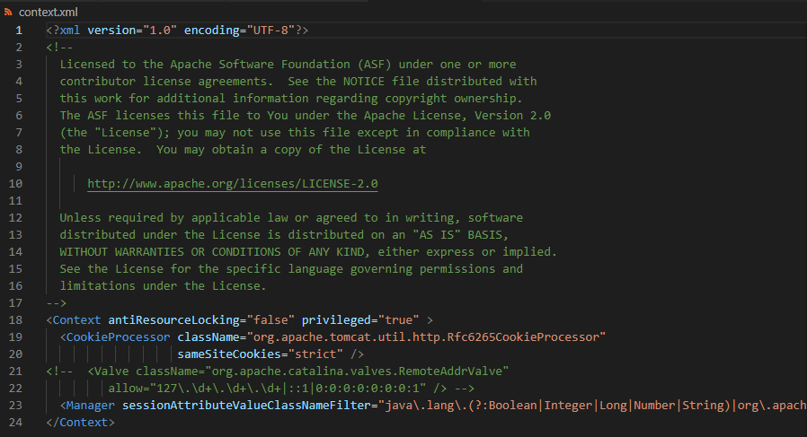

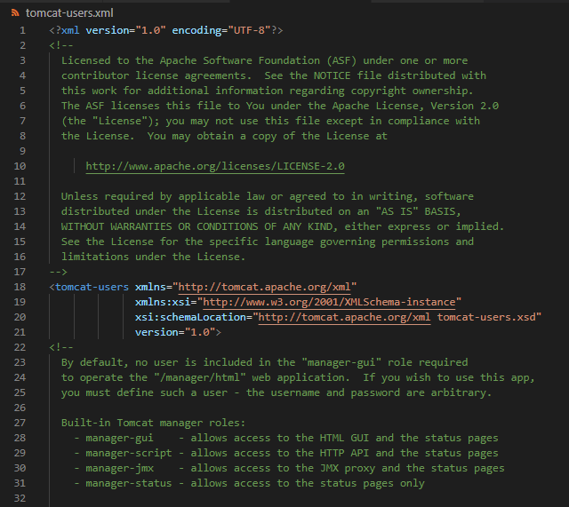

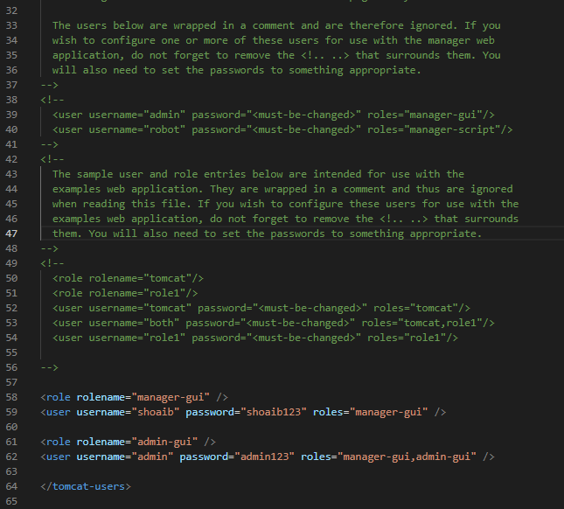

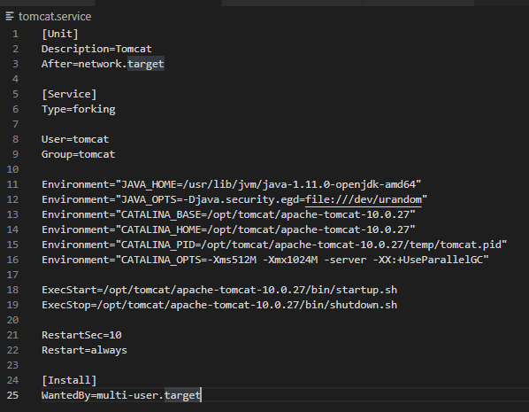

* Run the playbook in localhost.

**$** 🡪 **(ansible-playbook main.yml)**

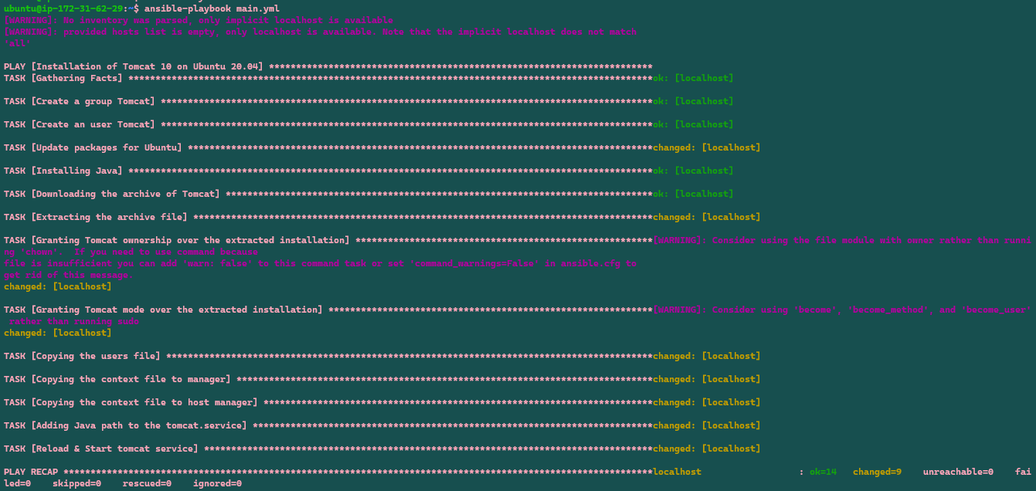

* Check the status of Tomcat. If It shows active(running), then access Tomcat through web browser.

**$** 🡪 **(sudo systemctl status tomcat)**

